Project Status Report

数字校园

V 1.0

Erin Wang
Project Manager



Sep 5, 2001

Document Control

Change Record

Date | Author | Version | Change Reference
9/5/2001 | Erin Wang | V1.0

Reviewers

Date | Name | Position
9/5/2001 | John, Erin

Approved By

Name | Position | Signature | Date
The copy numbers referenced above should be written into the Copy Number space on the cover of each distributed copy. If the document is not controlled, you can delete this table and the Copy Number label from the cover page.

CONTENTS

1. Customer Complains 4
2. Milestones/Tasks Achieved 4
3. Milestones/Tasks Planned for next period 4
4. Quality Assurance Activities 4
5. Issues 4
6. Number of Requirement Change Request 5
7. Major Changes from the Plan 5

Customer Complains
No teacher monitor showing system.

Milestones/Tasks Achieved
Milestones/Tasks | Status | Remark | Deliverables | Delay
Software Development | Complete |  | Software development plan  Configuration management plan  Software quality assurance plan | 8 days

Milestones/Tasks Planned for next period
Time: Aug17 – Sep7
Milestone: High Level Design
Deliverables:
- User Interface Design
- Function and architecture design
- Database design

Quality Assurance Activities
QA Activity | Defects detected | Defects closed | Defects open
Software development plan  plan | 1 | 1 | 0
Configuration management | 0
Software quality assurance plan | 0

Issues
No. | Issue | Raised by | Action by | Status
1 | Change the SDP in every period | John Wang | Erin Wang | Open
2 | Add the Gantt Chart in Status report | John Wang | Erin Wang | Open
3 | Add the risk of tech in next version SDP | John Wang | Erin Wang | Open
4 | Make estimation before the Detail Design | John Wang | John Wang | Open

Number of Requirement Change Request

Major Changes from the Plan
Start the HLD with SDP, because the time limited.
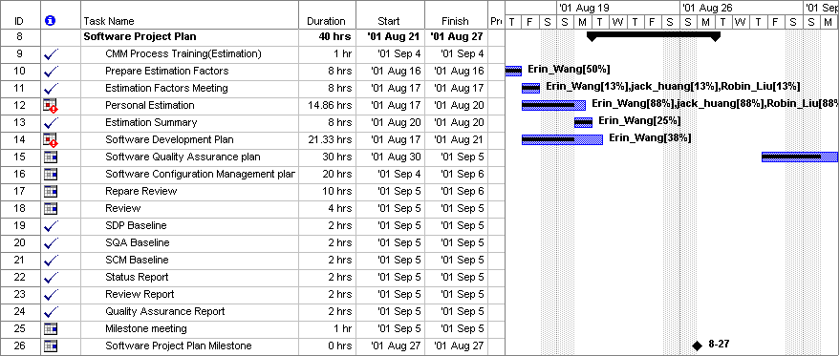
Standard Tailoring Record

Delete Item:
Item Name | Reason
Add Item:
Item Name | Reason
Modify Item:
Item Name | Reason | Modification

